Date: 09th November 2023
Our reference: SLBRIDGE2023/02/EU
IMPORTANT INFORMATION that affects YOU from
Westmorland and Furness Council Highways – Please read today

To Whom It May Concern,
Westmorland and Furness Council is seeking comments and objections on proposals. The purpose of this consultation is to offer you the opportunity to let us know what you think about the proposals described on pages 3 and 4 and the corresponding plans. We are writing to inform you of the proposals and to allow you to comment or object before a decision on the final scheme, and whether to implement the restrictions, is made.
This statutory consultation gives you the opportunity to make your comments for consideration in the final decision. The consultation and objection period is 21 days and the deadline for replies is 30th November 2023.
Please find enclosed the following documents:
- Statement of reasons for the proposals
- Statutory notices
- Drawing SLBRIDGE2023.02.1.1 Middle Fell Bridge - Prohibition of Motor Vehicles
- Drawing SLBRIDGE2023.02.2.1 Main Drain Bridge - 7.5 Tonnes Maximum Gross Vehicle Weight Limit
- Drawing SLBRIDGE2023.02.2.2 Water Yeat Bridge - 7.5 Tonnes Maximum Gross Vehicle Weight Limit
- Drawing SLBRIDGE2023.02.2.3 Bridge End Bridge - 7.5 Tonnes Maximum Gross Vehicle Weight Limit
- Drawing SLBRIDGE2023.02.2.4 Fell Foot Bridge - 7.5 Tonnes Maximum Gross Vehicle Weight Limit
- Drawing SLBRIDGE2023.02.3.1 Newland Mill Bridge - 10 Tonnes Maximum Gross Vehicle Weight Limit

Feedback
The consultation and advertising period is from date. Please email your comments and objections to TROconsultation@westmorlandandfurness.gov.uk , or by post to the address below or handed in to County Hall Reception, the attention of the Traffic Management Team with Reference SLBRIDGE2023.02/EU. Deadline for replies is 30th November 2023.
When will the proposals be finalised and implemented on the ground?
Following advertising and consultation on the proposals, a report will be prepared to go before the Council Locality Board for South Lakeland in January 2024. The Committee will make the final decision as to what will be implemented. We will endeavour to inform you of the committee decision in due course. If the Committee agree to implement the proposals, the making of the traffic order and the placing of signs and markings should take place within a 3 to 4 month period after the decision.
Yours sincerely
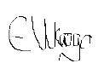
Emma Ukaogo - Traffic Management Officer

WESTMORLAND AND FURNESS COUNCIL (VARIOUS BRIDGES – SOUTH LAKELAND AREA) (TRAFFIC REGULATION) ORDER 20><

1. Westmorland and Furness Council hereby give notice that it proposes to make the
above Order under Sections 1 and 2 of the Road Traffic Regulation Act 1984.
2. The effect of the proposed Order will be to: -
i) Prohibit all motor vehicles from proceeding along that length of the U5528 heading towards Middle Fell Farm, near Great Langdale, from a point 24 metre
north of the centre of its junction with the U5528 towards Stool End, extending over the full expanse of Middle Fell Bridge.
ii) Introduce a 7.5 Tonnes maximum gross vehicle weight limit on the following
Bridges;
a) U5614 Main Drain Bridge, near Levens;
b) U5082 Water Yeat (Old) Bridge, near Water Yeat;
c) U5001 Bridge End Bridge, near Little Langdale; and
d) U5001 Fell Foot Bridge, near Little Langdale.
iii) Introduce a 10 Tonnes maximum gross vehicle weight limit on the U5518
Newland Mill Bridge, near Newland Bottom.
(NB: There are no exemptions to the above proposed restrictions).
PLEASE REFER TO THE DOCUMENTS ON DEPOSIT AND ON THE COUNCIL’S WEB-SITE FOR FULL DETAILS.
3. Full details of the proposed Order, together with plans showing the lengths of road concerned, and a statement of the Council's reasons for proposing to make the Order,
may be: -
(i) viewed on the Council’s website using the following link: -;
https://www.westmorlandandfurness.gov.uk/parking-streets-and- transport/streets-roads-and-pavements/road-maintenance-closures-and- improvements/proposed-traffic-regulation-orders-tros
(ii) on deposit at;
(a) Ambleside Library, Kelsick Road, Ambleside, LA22 0BZ;
(b) County Hall, Kendal, LA9 4RQ;
(iii) at the offices of the undersigned; and
(iv) may otherwise be obtained by emailing TROconsultation@westmorlandandfurness.gov.uk

4. If you wish to comment or make representations in relation to the proposals, you should write to the Traffic Management Team, County Hall, Kendal, Cumbria, LA9
4RQ, or by email to TROconsultation@westmorlandandfurness.gov.uk by 30 November 2023, marking your correspondence with reference SLBRIDGE2023/02/EU.
Chief Legal Officer, Westmorland and Furness, South Lakeland House, Lowther Street, Kendal, LA9 4DQ
Dated 9 November 2023

WESTMORLAND AND FURNESS COUNCIL (VARIOUS BRIDGES – SOUTH LAKELAND AREA) (TRAFFIC REGULATION) ORDER 20><

STATEMENT OF REASONS
Westmorland and Furness Council considers that it is expedient to propose make the above
Order for the following reason (s) in Section 1(1) Road Traffic Regulation Act 1984:

(a) for avoiding danger to persons or other traffic using the roads or any other roads or for preventing the likelihood of any such danger arising, or
(b) for preventing damage to the roads or to any building on or near the roads, or (d) for preventing the use of the roads by vehicular traffic of a kind which, or its use by vehicular traffic in a manner which, is unsuitable having regard to the existing character of the roads or adjoining properties.

For the following:
Middle Fell Bridge - Prohibition of Motor Vehicles
(Drawing SLBRIDGE2023.02.1.1)
The issues with this bridge, which have led to us deciding to prohibit motorised vehicles over
it are as follows:
• The bridge has been assessed as capable of carrying vehicles up to 10 tonnes weight.
As a weak bridge, it should be signed with a weight restriction. However, the required signage at this location would be detrimental to the character of the area, with consideration of the nature of the approaches (agricultural field to the north), the confines of the approaches (narrow walled track to the south), and the character of the area (picturesque tourist location).
• The road carried by the bridge is unsurfaced; at the bridge there is a thin layer of
cobbles laid directly onto the extrados of the structural arch barrel. Tracking of motorised vehicles over the bridge will therefore be causing damage to the structure of the bridge because of lack of distribution of wheel loads. Further surfacing of the road would cause detriment to the character of the area by significantly altering the appearance of the bridge, including the need to increase the height the parapets of the arch to accommodate thickness of the road surface.
• It is evident on site that all vehicle accessing Middle Fell Farm and the field
immediately to the north of the Middle Fell Bridge are using the adjacent spur of the
U5528 over Dungeon Ghyll Bridge as an alternative, therefore this alteration to
access, we believe, would not be a deviation from present preferred routes to access properties over the bridge.
Main Drain Bridge - 7.5 Tonnes Maximum Gross Vehicle Weight Limit
(Drawing SLBRIDGE2023.02.2.1)
Water Yeat Bridge - 7.5 Tonnes Maximum Gross Vehicle Weight Limit
(Drawing SLBRIDGE2023.02.2.2)
Bridge End Bridge - 7.5 Tonnes Maximum Gross Vehicle Weight Limit
(Drawing SLBRIDGE2023.02.2.3)
Fell Foot Bridge - 7.5 Tonnes Maximum Gross Vehicle Weight Limit
(Drawing SLBRIDGE2023.02.2.4)
An inspection and structural assessment of the Bridges named above has found that each bridge is incapable of carrying any load exceeding 7.5 tonnes without unacceptable risk to members of the public and or damage to the road and structure.
This Traffic Regulation Order is proposed to prohibit all vehicles proceeding along the bridge extents.

Newland Mill Bridge - 10 Tonnes Maximum Gross Vehicle Weight Limit
Drawing SLBRIDGE2023.02.3.1
An inspection and structural assessment of Newland Mill Bridge has found that it is incapable of carrying any load exceeding 10 tonnes without unacceptable risk to members of the public and or damage to the road and structure. We therefore propose a Traffic Regulation Order as a result of the weak bridge.
This Traffic Regulation Order is proposed to prohibit all vehicles proceeding along the bridge extents.
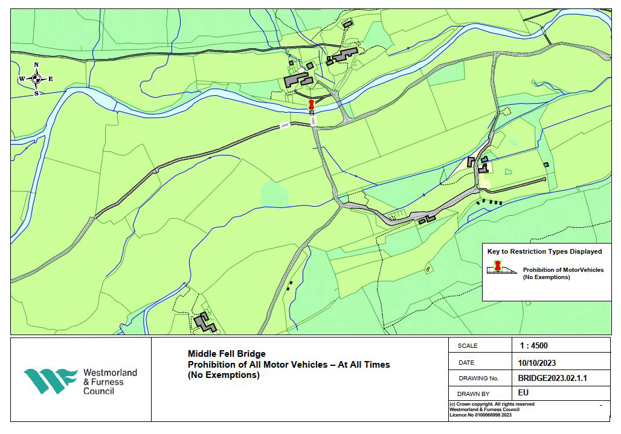
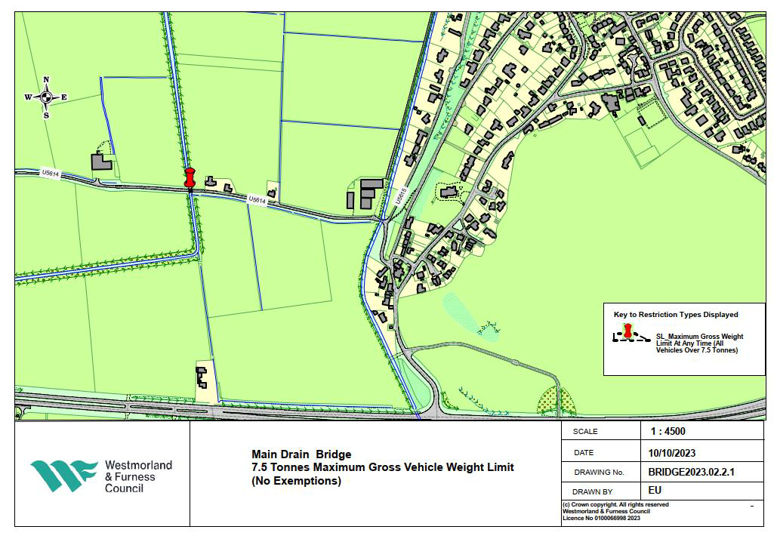
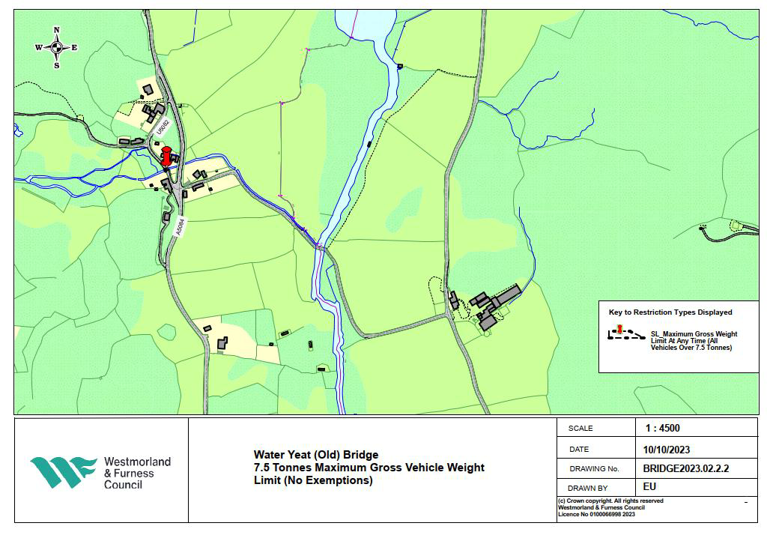
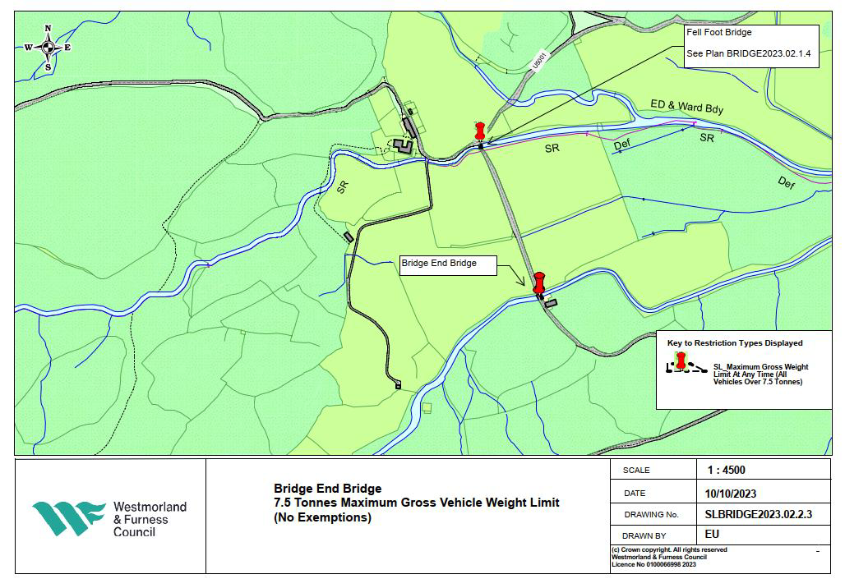
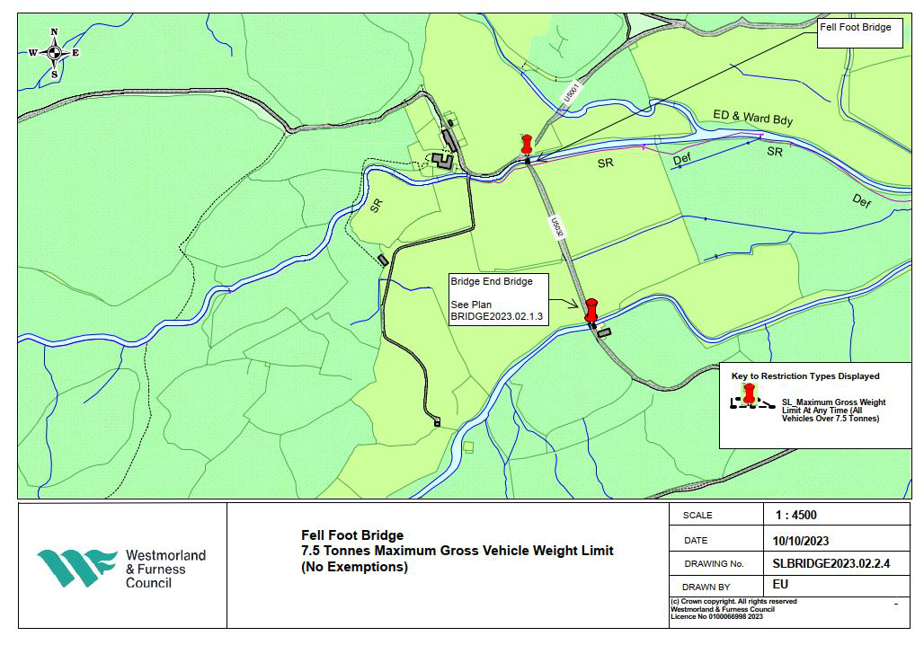
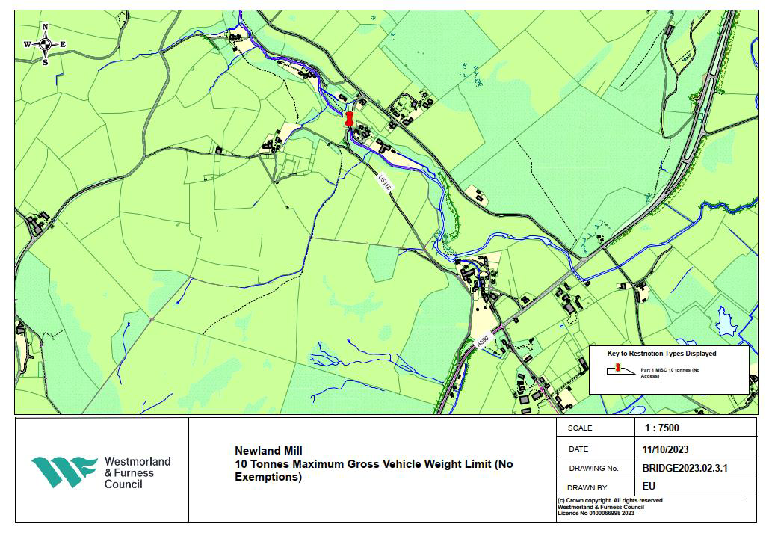

WESTMORLAND AND FURNESS COUNCIL
(VARIOUS BRIDGES – SOUTH LAKELAND AREA) (TRAFFIC REGULATION) ORDER 20><

Westmorland and Furness Council, in exercise of its powers under Sections 1(1) and 2(1) to (4) of the Road Traffic Regulation Act 1984 of the Road Traffic Regulation Act 1984 ("the Act") and of all other enabling powers and after consultation with the
Chief Constable of Cumbria in accordance with Part III of Schedule 9 to the Act hereby makes the following Order:-
1. This Order shall come into operation on >< and may be cited as Westmorland
and Furness Council (Various Bridges – South Lakeland Area) (Traffic Regulation) Order 20><
ARRANGEMENT OF ARTICLES

Article(s) Parts

Part I - General
1 – 4 Citation, Commencement, Interpretation etc.

Part II – Prohibition of All Motor Vehicles (No exemptions) 5 General

Part III – Weight Limits – Bridges (No Exemptions)
6 7.5 Tonnes Maximum Gross Weight Limit 7 10 Tonnes Maximum Gross Weight Limit 8 Interpretation Act

PART I
GENERAL
2. In this Order, except where the context otherwise requires, the following
expressions have the meanings hereby respectively assigned to them:-

(1) “junction” means, unless otherwise indicated in this Order, the intersection of the general alignment of the highway boundaries of two
roads;
(2) “motor vehicle” means a mechanically propelled vehicle intended or
adapted for use on roads;
(3) “road” means the full width of the highway including the carriageway
and footway;
(4) “traffic sign” means a sign or marking of any size colour and type prescribed or authorised under, or having effect as though prescribed
or authorised under, Section 64 of the 1984 Act;
(5) “the 1991 Act” means the Road Traffic Act 1991;

3. The restrictions imposed by this Order shall be in addition to and not in derogation of any restriction or requirement imposed by any Regulations
made or having effect as if made under the Act of 1984, The Road Traffic Act 1991, or by or under any other enactment.
4. The Council is satisfied that for preventing the likelihood of danger arising to
persons or other traffic using the road or roads hereinafter mentioned it is requisite that Section 3(1) of the Act shall not apply in relation to the lengths of road specified in Articles 5 to 7 inclusive of this Order.

PART II
PROHIBITION OF ALL MOTOR VEHICLES (NO EXEMPTIONS)

5. No person shall proceed or cause or permit any motor vehicle to proceed in
the length of road specified in Schedule 1 of this Order.

PART III
WEIGHT RESTRICTIONS – BRIDGES (NO EXEMPTIONS)

7.5 Tonnes

6. No person shall cause or permit any motor vehicle, the maximum gross weight of which exceeds 7.5 tonnes, to proceed along the lengths of road
specified in Schedule 2 to this Order.
10 Tonnes

7. No person shall cause or permit any motor vehicle, the maximum gross
weight of which exceeds 10 tonnes, to proceed along the lengths of road
specified in Schedule 3 to this Order.
8. The Interpretation Act 1978 shall apply for the interpretation of this Order as it
applies for the interpretation of an Act of Parliament.

Dated the >< day of >< 20><

THE COMMON SEAL OF )
WESTMORLAND AND FURNESS COUNCIL ) was hereunto affixed )
in the presence of:- )

Authorised Signatory ……………………………………..

Schedule 1
Prohibition of All Motor Vehicles (no exemptions_)

Location Restricted Length

1 U5528 near Great
Langdale

That length of the U5528 heading towards Middle Fell Farm, near Great Langdale, from a point 24 metre north of the centre of its junction with the U5528 towards Stool End, extending over the full expanse of Middle Fell Bridge.

Schedule 2
Prohibition of Motor Vehicles over 7.5 Tonnes M.G.W (No Exemptions)

Location Restricted Length

1

2

3

4

U5614 near Levens (Main Drain Bridge)

U5082 near Water Yeat
(Water Yeat (Old) Bridge)

U5001 near Little Langdale
(Bridge End Bridge)

U5001 near Little Langdale
(Fell Foot Bridge)

That length of the U5614 Old Road heading towards Sampool, near Levens, from a point approximately 340 metres west of the centre of its junction with the U5615, extending over the full expanse Main Drain Bridge

That length of the U5082, near Water Yeat, from a point approximately 30 metres north westwards, towards the village hall, from the centre of its southernmost junction with A5084, extending over the full expanse of Water Yeat (Old) Bridge

That length of the U5001, near Little Langdale, from a point approximately 260 metres south-east of the centre of its junction with U5032, by Fell Foot Bridge, extending over the full expanse of Bridge End Bridge.

That length of the U5001, near Little Langdale, from a point 5 metres south-east of the centre of its junction with U5032 extending over the full expanse of Fell Foot Bridge.

Schedule 3
Prohibition of Motor Vehicles over 10 Tonnes M.G.W (No Exemptions)

Location Restricted Length

1 U5518 near Newland
Bottom
(Newland Mill Bridge)

That length of the U5118, near Newland Bottom, from a point approximately 820m north west of its junction with the A590 at Newland, extending over the full expanse of Newland Mill Bridge.

